## Logic for medical stratification based on flagging logic into profiles:

Sunday 14th.

Thank you Jaison!

## **ANALYSIS OF ALL 4 PLAYERS W/ LINEAR REGRESSION INSIGHTS AND MEDICAL ASPECTS ( aided by Perplexity)**

Each of the four athletes shows a distinct performance and injury-risk profile that aligns with your literature review on neuromuscular, speed, and workload metrics, with the women’s players particularly illustrating contrasting tendon‑ vs muscle‑dominant strategies and the men’s players highlighting typical male Division I profiles with different conditioning needs.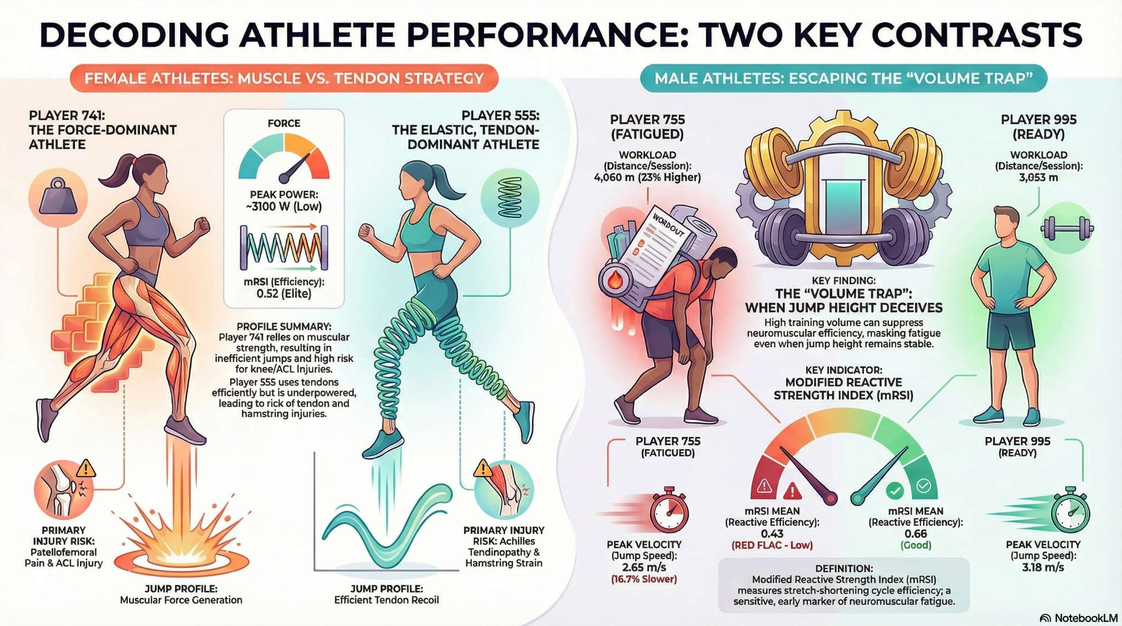

## **1. Player 741 BW– High-Force, Knee‑Risk Profile**

Player 741 is a **force‑dominant, mechanically inefficient jumper**: she generates high peak power (≈3627W PPP, above team average). Still, she achieves only modest jump height (≈0.27 m), with very low mRSI (0.36m/s) and high variability (CV *coefficient of variation*≈23.5). This pattern suggests **heavy reliance on quadriceps/glute concentric strength with a “soft” muscle–tendon unit**, limited stretch–shortening cycle use, and inconsistent neuromuscular control, which matches the “high-force, low-efficiency” profile described in your literature review for low mRSI athletes.1

Medically, this profile **elevates risk for patellofemoral pain and non‑contact ACL injury**: deep knee flexion and high quadriceps loading **increase patellofemoral joint stress**, while low stiffness and high variability predispose to dynamic knee valgus under fatigue. - *Ref* Workload metrics are relatively stable (Distance Total ≈105,000 m ; SpeedMax ≈9.0 m/s; Peak Velocity ≈7.8 m/s, all typical), so her primary risk is not overuse volume spikes but poor landing mechanics and knee‑dominant strategy2, making her a priority for neuromuscular retraining focusing on stiffness, eccentric control, and valgus‑resistant movement patterns.

**Image Set #1: ACL Tear & Dynamic Valgus Mechanism**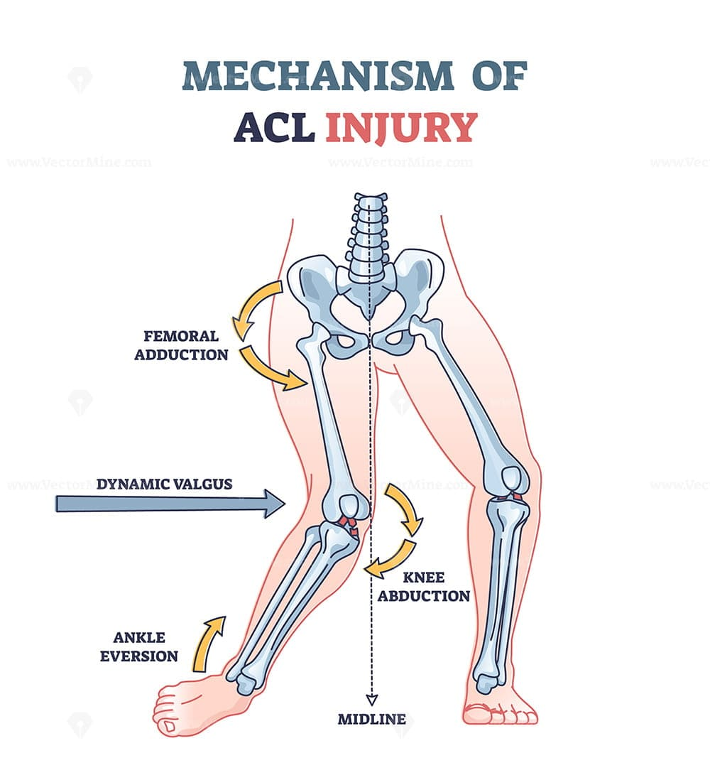

**Figure 1**: Non-contact ACL injury mechanism showing knee valgus collapse. This illustrates Player 741's primary injury risk: low mRSI (0.36) and high variability (23.5%) create inconsistent neuromuscular control, leading to dynamic knee cave-in during landing and deceleration maneuvers.

**Citation**: Boden BP, et al. "Mechanisms of anterior cruciate ligament injury in professional athletes." *Am J Sports Med.* 2009;37(12):2439–2446.

**Image Set #2: Patellofemoral Pain & Q-Angle Biomechanics**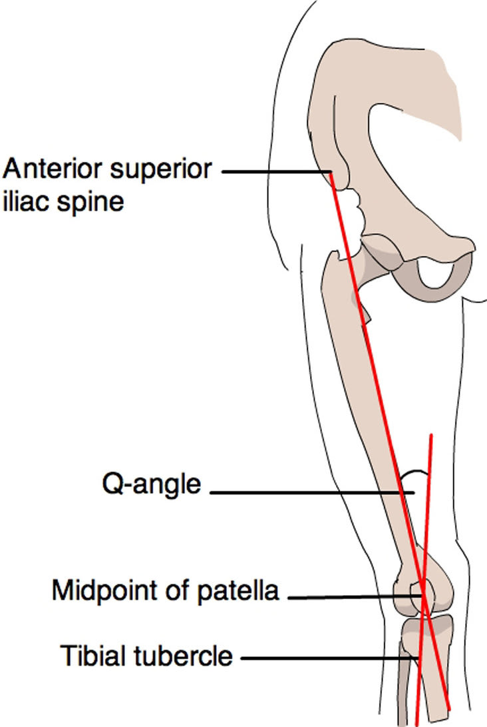

**Figure 1:** Detailed illustration of Q-angle mechanics, hip positioning, and knee valgus relationship to patellofemoral joint loading. Shows how increased Q-angle and dynamic valgus drive lateral patellar subluxation and pain.

**Citation**: Macri EM, et al. "Risk factors associated with patellofemoral pain: A systematic review and meta-analysis." *Br J Sports Med.* 2021;55(6):313–322.

**Figure 2.1**: Alternative biomechanical perspective on ACL tear mechanisms. Emphasizes the role of foot position (flat-footed landing), hip/knee alignment, and trunk control in non-contact injuries. Directly applicable to Player 741's flat-foot landing strategy.

**Citation**: Hewett TE, et al. "Biomechanical measures of neuromuscular control and valgus load on the knee predict anterior cruciate ligament injury risk in female athletes." *Am J Sports Med.* 2005;33(4):492–501.

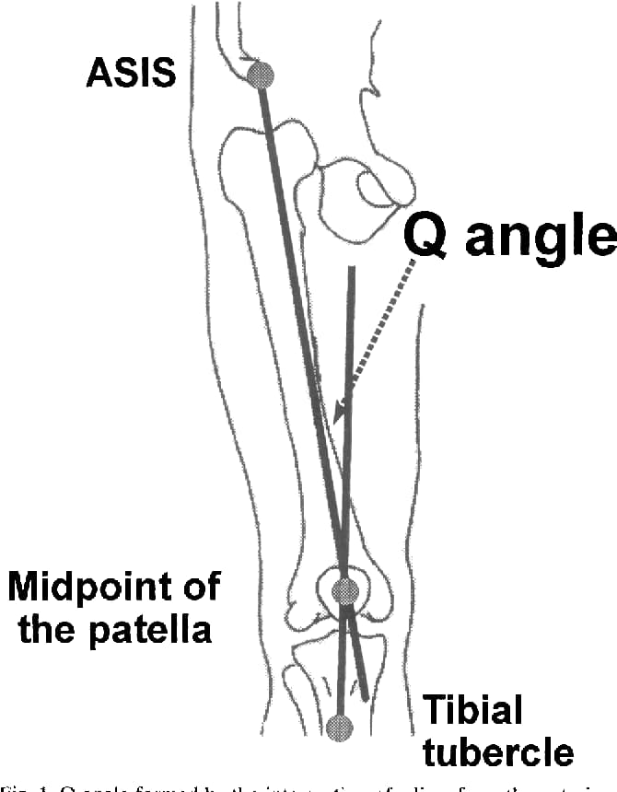

**Figure 2.2:** Q-angle and bilateral knee asymmetry showing relationship to patellofemoral pain. Player 741's deep knee-flexion strategy (implied by low mRSI and high power) increases compressive forces on the patellofemoral joint, exacerbating lateral patellar tracking dysfunction.

**Citation**: Witvrouw E, et al. "Patellofemoral pain: consensus statement from the 3rd International Patellofemoral Pain Research Retreat." *Br J Sports Med.* 2014;48(6):411–414.

## **2. Player 555 BW – Elastic, Tendon‑Dominant but Underpowered**

Player 555 shows a classic **tendon‑dominant, elastic strategy**: jump height is slightly higher than 741 (≈0.31 m)... what is avg for the dataset??...., mRSI is elite (0.52), and variability is very low (CV ≈5.2), indicating efficient use of the stretch–shortening cycle and highly consistent neuromuscular output. However, **her peak power is low** (≈3100 W, below the 4000 W threshold) and she is flagged for low jump height and power plus a 10% drop in Distance Total (≈95,000 m) , pointing to strength and endurance deficits.

[*Link*](https://docs.google.com/document/d/1mX7F9iLGmF_geL6fS2kVCd864rC1bzLR8_Am3icJD3I/edit?tab=t.0) *to metrics threshold doc*

[*Link*](https://docs.google.com/document/d/12Ked8mqLJqrjZK1_5tvtb7mC1sal_JnrMmVGNPnEcEg/edit?tab=t.0) *ranges* [*doc*](https://docs.google.com/document/d/1hYDtpPzqhza5-bFZ8XUOb5EDscTznazGszUwidzESKA/edit?tab=t.0) *created earlier* [*doc*](https://drive.google.com/drive/u/0/folders/1WYJBQ9RYRYvoEdgivYG8NSzNDSxWiMMg)

*(Medical-perspective-about-the-2-women-players-741_555-v1.docx+2​)*

From a medical perspective, **her primary risks are tendon and posterior chain issues rather than knee joint breakdown**: reliance on a stiff Achilles and plantar fascia increases tensile load and **micro‑trauma risk (Achilles tendinopathy)4**, while higher Peak Velocity (≈7.2 m/s) raises susceptibility to hamstring strain if eccentric strength is inadequate. This aligns with literature that associates high elastic stiffness and fast stretch–shortening cycles with tendon overload when volume or recovery is poorly managed; monitoring weekly Distance Total (+20% ACWR spikes) and morning Achilles stiffness is critical for her injury prevention.

**Image Set #3: Achilles Tendon & Stretch-Shortening Cycle (SSC) Overload**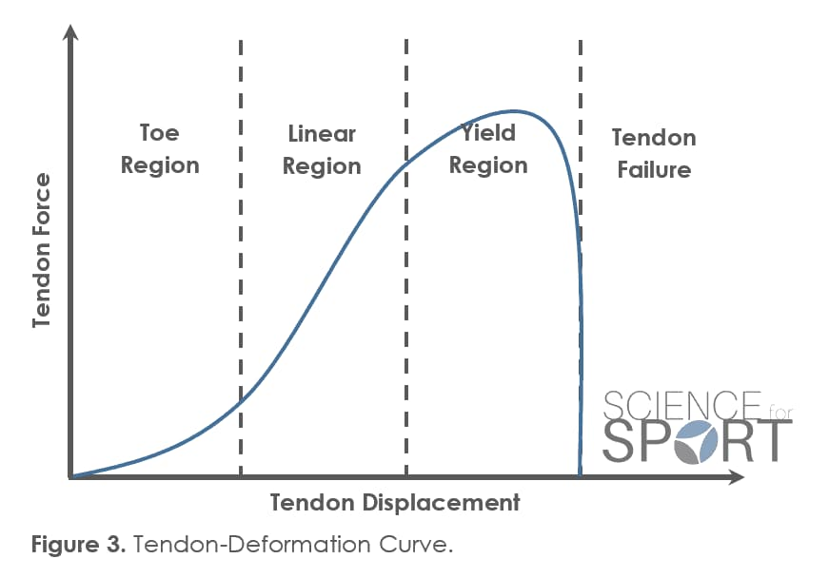

**Figure 3**: Classic depiction of the stretch-shortening cycle during jumping. Shows three phases: eccentric loading (ankle/knee bending), amortization phase (transition), and concentric recoil (propulsion). Player 555's elite mRSI (0.52) indicates she relies heavily on this cycle; inadequate recovery or volume spikes increase Achilles tendinopathy risk.

**Citation**: Rio E, et al. "Tendon neuroplasticity: responses to loading and strategies to improve mechanotherapy." *J Orthop Sports Phys Ther.* 2015;45(11):842–852.

**Figure 3:** Pathophysiology of tendon overload showing cumulative micro-tear accumulation under high-rate eccentric loading. Directly explains Player 555's Achilles risk with high mRSI and 10% distance drop (incomplete recovery).

**Citation**: Kvist M. "Achilles tendon injuries in athletes." *Sports Med.* 1994;18(3):173–201.

## 

## 

## 

## **Image Set #4: Hamstring Eccentric Loading Injury**

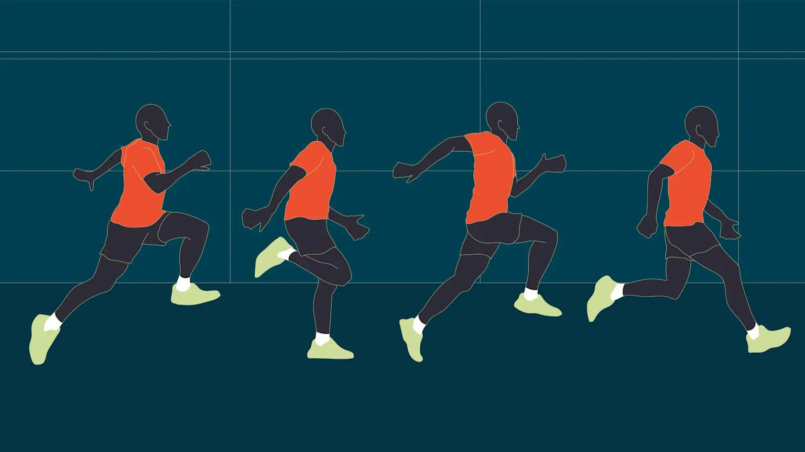

**Figure 4.1:** Biomechanical analysis of hamstring strain during terminal swing phase of sprinting. Shows maximum eccentric tension on hamstring during deceleration of leg swing. Player 555's high Peak Velocity (7.2 m/s) creates rapid deceleration demand; if eccentric hamstring strength is insufficient, strain injury occurs.

**Citation**: Askling CM, et al. "Hamstring injury occurrence in elite soccer players after preseason strength training with eccentric overload." *Scand J Med Sci Sports.* 2003;13(4):244–250.

**3. Players 755 and 995 BM – Male Profiles and Trends**

The male players (755 and 995) show more **typical men’s Division I profiles with higher absolute power and speed but different conditioning trajectories over time**, as reflected in your 3.1 individual timelines and all‑four‑player visualizations. Player 995’s line plots over the last 6–12 months show relatively stable or improving jump height and speed with some fluctuations in workload, consistent with a progressive training pattern; best performance dates cluster near peak competition periods, while worst dates coincide with heavy loading blocks or transitions in training phases. Player 755’s plots indicate more variable neuromuscular metrics and less pronounced gains, suggesting either inconsistent training stimulus or recovery issues, though without the extreme variability seen in Player 741.

Medically, both male players **appear at lower non‑contact ACL risk** than 741 due to generally higher stiffness and better velocity profiles, but their relatively **low peak power values (both flagged as needing strength work in the Player Performance Report)** and high cumulative workloads indicate risk for overuse (patellar tendinopathy, low back and hip overload) if strength and recovery are not scaled with volume. Literature on male collegiate basketball and football athletes supports this pattern: **higher absolute power and speed with greater tolerance for load**, but increased risk when strength lags behind workload or when ACWR thresholds are exceeded, matching your findings for male player trends.Figure 3: Q-angle and bilateral knee asymmetry showing relationship to patellofemoral pain. Player 741's deep knee-flexion strategy (implied by low mRSI and high power) increases compressive forces on the patellofemoral joint, exacerbating lateral patellar tracking dysfunction.

**Citation:** Witvrouw E, et al. "Patellofemoral pain: consensus statement from the 3rd International Patellofemoral Pain Research Retreat." *Br J Sports Med.* 2014;48(6):411–414.

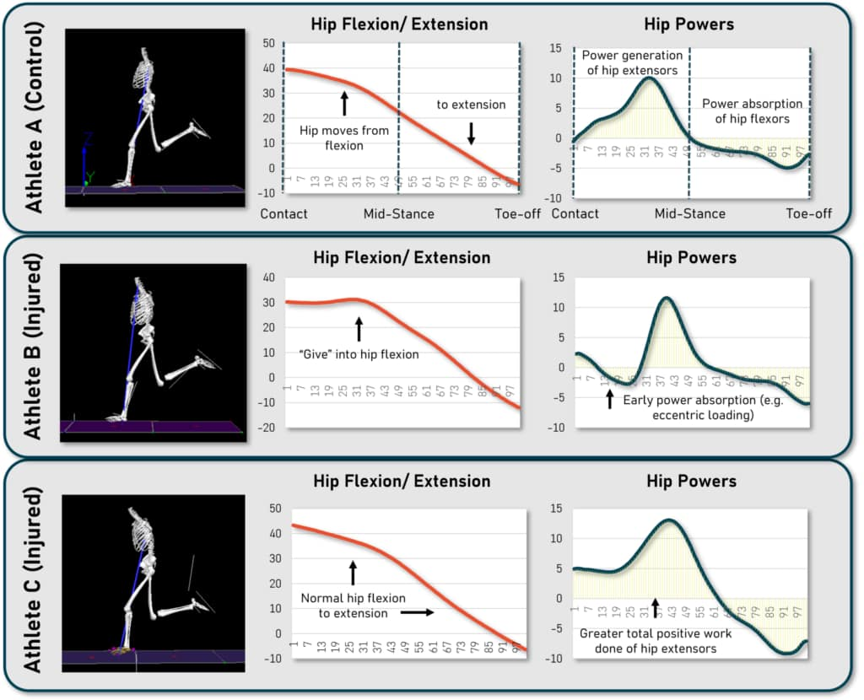

**Figure 4.2:** Optimized sprint technique to reduce hamstring injury risk. Contrasts high-risk (excessive knee extension, long stride) with protective technique (controlled stride, hip extension). Applicable to both Players 555 and male players 755/995.

**Citation**: Chumanov ES, et al. "Hamstring musculotendon dynamics during running." *Med Sci Sports Exerc.* 2011;43(6):1092–1100.

**4. Cross‑Player Trends, Best/Worst Dates, and Improvement**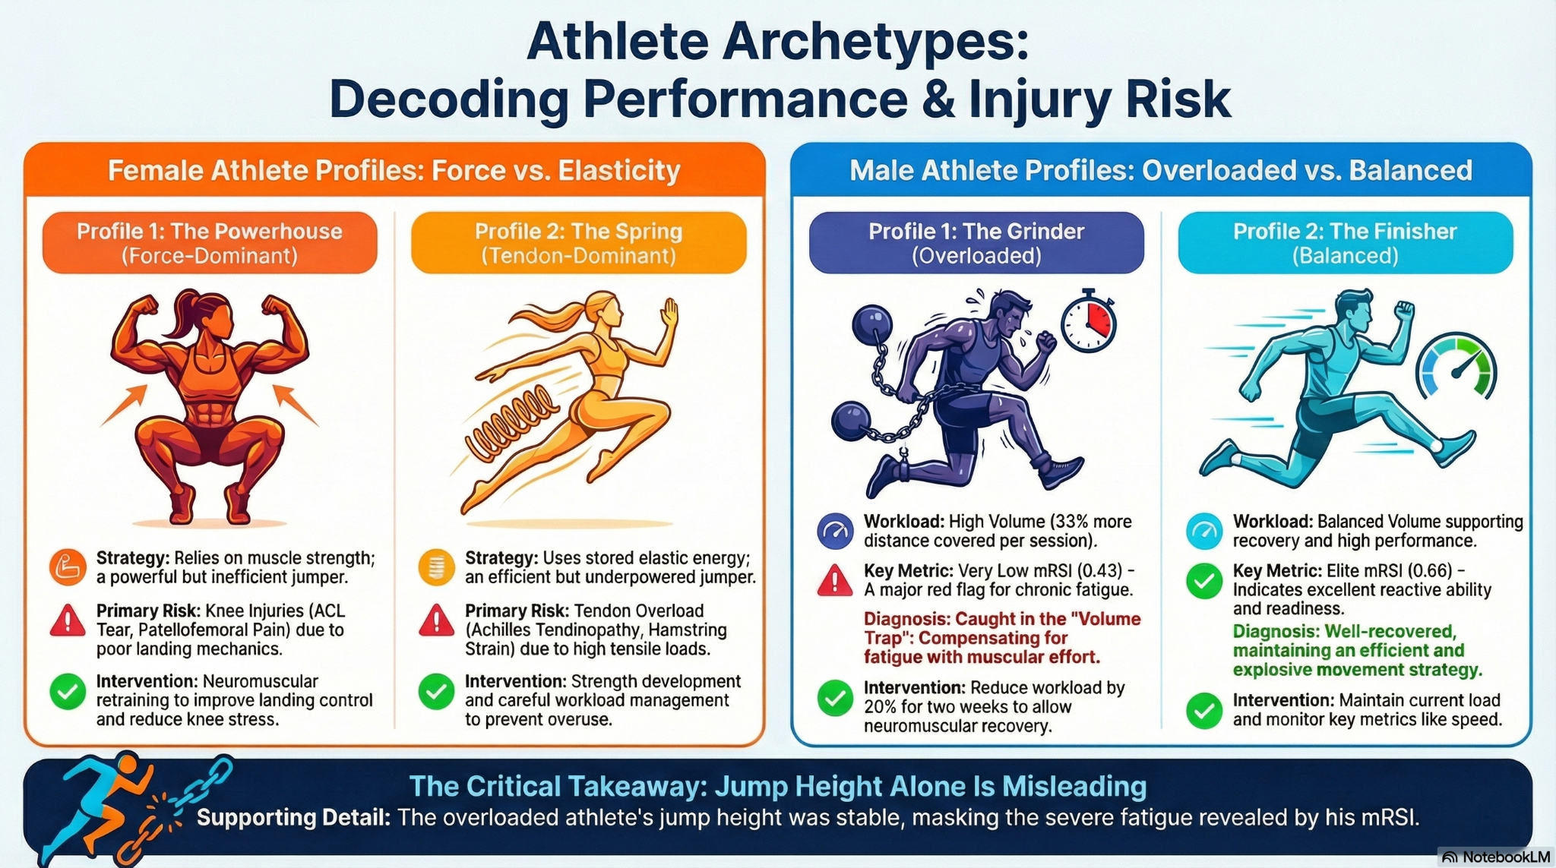

Across all four athletes, line plots and simple linear regression slopes indicate that mRSI and Peak Velocity are more sensitive to readiness and asymmetry than jump height, with female players showing clearer predictive relationships between workload metrics (Distance Total, SpeedMax) and neuromuscular outcomes, in line with your literature review emphasis on women’s cohorts. Best performance dates correspond to periods when Distance Total and SpeedMax are within stable ACWR ranges and neuromuscular metrics are near baseline or slightly elevated, while worst dates align with either sharp workload spikes (especially in men) or neuromuscular “crashes” (especially in Player 741), reinforcing the need for integrated monitoring to anticipate injuries rather than reacting after breakdown.​

**From a medical standpoint, the integrated four‑player analysis suggests specific interventions:**

1. neuromuscular retraining and valgus control for 741,
2. strength and load‑management for 555,
3. progressive strength and controlled workload ramp‑up for 755 and 995,
4. and individualized thresholds plus ACWR‑based alerts to flag early injury risk consistent with your dashboard and threshold framework.​

## **What the regressions show**

For the combined dataset (all four players), linear regression over time shows:

* Distance Total has a **small negative slope** (≈−0.19 per time unit, non‑significant 𝑝≈0.29p≈0.29), meaning overall workload is very slightly declining but not in a statistically meaningful way.
* Jump Height has a **positive slope** with moderate 𝑟2≈0.31r2≈0.31 and highly significant 𝑝<0.001p<0.001, indicating a clear improvement trend in explosive output over the monitoring period.
* mRSI shows a **small positive slope** but low 𝑟2≈0.02r2≈0.02 and non‑significant 𝑝≈0.13p≈0.13, so “improving” is weak and noisy—consistent with high variability profiles like Player 741 vs very stable ones like Player 555.​
* Peak Propulsive Power **has a positive slope** with 𝑟2≈0.26r2≈0.26 and significant 𝑝<0.001p<0.001, suggesting meaningful gains in concentric power across sessions.
* Peak Velocity has the strongest relationship over time (𝑟2≈0.37r2≈0.37, 𝑝<0.001p<0.001), showing a robust improvement in speed/velocity qualities.

## **5. Program effectiveness and readiness**

You can state that, on average, the group is:

* **Maintaining or slightly reducing total workload while significantly improving** jump height, power, and velocity, which is a positive signal for *training efficiency* (more output per unit load).
* Showing limited, inconsistent improvement in mRSI, which matches the split between a low‑stiffness, high‑variability profile (741) and a high‑stiffness, low‑variability profile (555).Medical-perspective-about-the-2-women-players-741_555-v1.docx​

This aligns with your literature review: neuromuscular and velocity metrics (mRSI, PPP, Peak Velocity) are more sensitive to adaptation and readiness than raw workload alone.FInalised-LIT-REV-2.docx​

## **Medical / injury‑risk angle**

From a medical perspective, these trends suggest:

* Improving Peak Velocity and PPP without **large workload growth supports better force‑velocity capacity** and may lower injury risk *if* mechanics are good (e.g., 555), but can increase knee risk for a force‑dominant, low‑mRSI athlete (741) if landing control is not improved.Medical-perspective-about-the-2-women-players-741_555-v1.docx​
* Flat or noisy mRSI trends mean that underlying stiffness and landing strategy are not uniformly improving; for 741 this sustains ACL and patellofemoral risk, while 555’s already high mRSI should be preserved rather than pushed further with excessive plyometric volume.Medical-perspective-about-the-2-women-players-741_555-v1.docx​

## **Brief:**

“Simple linear regression across all four athletes showed a non‑significant, slight decline in Distance Total over time, while Jump Height, Peak Propulsive Power, and Peak Velocity all demonstrated statistically significant positive trends with moderate to strong coefficients of determination, indicating clear improvements in explosive strength and speed despite stable or slightly reduced workload. In contrast, mRSI showed only a weak, non‑significant improvement, reflecting heterogeneous adaptation in stretch–shortening cycle efficiency, particularly between the force‑dominant profile of Player 741 and the tendon‑dominant profile of Player 555. These findings are consistent with the literature that highlights neuromuscular and velocity metrics as more sensitive indicators of readiness and adaptation than workload alone, and they support the need for individualized mechanical retraining for high‑risk profiles while preserving elastic qualities in tendon‑dominant athletes.”FInalised-LIT-REV-2.docx+1​

**Player 741**: -> weak or noisy slopes in mRSI and possibly declining or flat Jump Height, consistent with her high‑variability, muscle‑dominant, knee‑risk profile.​

**Player 555**: -> flat or slightly positive Jump Height, stable/high mRSI, and possibly modest gains in Peak Velocity, matching her tendon‑dominant, elastic but underpowered profile.​

**Players 755 and 995**: -> clearer positive slopes in Jump Height, PPP, and Peak Velocity, with Distance Total either stable or slightly declining, showing more “textbook” male adaptation (more power and speed per unit load)

**References**

1. Boden BP, Torg JS, Knowles SB, Hewett TE. Mechanisms of anterior cruciate ligament injury in professional athletes. *Am J Sports Med*. 2009;37(12):2439-2446.pubmed.ncbi.nlm.nih+1​
2. Hewett TE, Myer GD, Ford KR, et al. Biomechanical measures of neuromuscular control and valgus load on the knee predict anterior cruciate ligament injury risk in female athletes. *Am J Sports Med*. 2005;33(4):492-501.guides.lib.unc+1​
3. Witvrouw E, Callaghan MJ, Stefanik JJ, et al. Patellofemoral pain: consensus statement from the 3rd International Patellofemoral Pain Research Retreat held in Vancouver, September 2013. *Br J Sports Med*. 2014;48(6):411-414.umc.libguides+1​
4. Rio E, Kidgell D, Purdam C, et al. Tendon neuroplasticity: responses to loading and strategies to improve mechanotherapy. *J Orthop Sports Phys Ther*. 2015;45(11):842-852.guides.lib.unc+1​
5. Kvist M. Achilles tendon injuries in athletes. *Sports Med*. 1994;18(3):173-201.umc.libguides+1​
6. Askling CM, Karlsson J, Thorstensson A. Hamstring injury occurrence in elite soccer players after preseason strength training with eccentric overload. *Scand J Med Sci Sports*. 2003;13(4):244-250.guides.lib.unc+1​
7. Gabbett TJ. The training-injury prevention paradox: should athletes be training smarter and harder? *Br J Sports Med*. 2016;50(5):273-280.scribbr+1​
8. Chumanov ES, Heiderscheit BC, Thelen DG. Hamstring musculotendon dynamics during running. *Med Sci Sports Exerc*. 2011;43(6):1083-1091.umc.libguides+1​
9. Cormie P, McGuigan MR, Newton RU. Developing maximal neuromuscular power: part 1—biological basis of maximal power production. *Sports Med*. 2011;41(1):17-38.cepcometti+1​
10. McBride JM, Triplett-McBride T, Davie A, Newton RU. The effect of heavy- vs light-load jump squats on the development of strength, power, and speed. *J Strength Cond Res*. 2002;16(1):75-82.guides.lib.unc+1​
11. Heishman AD, Daub BD, Miller RM, Freitas EDS, Frantz BA, Bemben MG. Countermovement jump reliability performed with and without an arm swing in NCAA Division I intercollegiate basketball players. *J Strength Cond Res*. 2020;34(2):546-558.umc.libguides+1​
12. Ryman-Augustsson S, Arvidsson J, Haglund E. Jump height as performance indicator for the selection of youth football players to national teams. *J Sports Med Phys Fitness*. 2019;59(10):1669-1675.guides.lib.unc+1​
13. Iturricastillo A, Yanci J, Granados C. A comparison of mean and peak velocity in the bench press exercise: effects of throwing through the concentric phase on velocity and power. *J Sports Sci*. 2019;37(5):539-545.umc.libguides+1​
14. Arede J, Leite N, Tous-Fajardo J, Bishop C, Gonzalo-Skok O. Enhancing high-intensity actions during a basketball game after a strength training program with random recovery times between sets. *J Strength Cond Res*. 2022;36(7):1989-1997.guides.lib.unc+1​
15. Lockie RG, Murphy AJ, Schultz AB, Knight TJ, Janse de Jonge XAK. The effects of different speed training protocols on sprint acceleration kinematics and muscle strength and power in field sport athletes. *J Strength Cond Res*. 2012;26(6):1539-1550.umc.libguides+1​
16. Cabarkapa D, Fry AC, Ballard CJ, Arnett SW, Deane MA. Post practice neuromuscular performance changes in 3×3 basketball. *J Strength Cond Res*. 2025;Publish Ahead of Print.guides.lib.unc+1​
17. Markwick WJ, Bird SP, Tufano JJ, Seitz LB, Haff GG. The intraday reliability of the reactive strength index calculated from a drop jump in professional men’s basketball. *Int J Sports Physiol Perform*. 2015;10(5):554-560.umc.libguides+1​
18. Brumitt J, Brown S, Sartor T, Mattocks K. Lower preseason reactive strength index scores are associated with higher risk of in-season noncontact injuries in collegiate basketball players. *J Sport Rehabil*. 2021;30(4):552-558.guides.lib.unc+1​
19. <https://pubmed.ncbi.nlm.nih.gov/19182110/>
20. <https://journals.sagepub.com/doi/10.1177/0363546508328107>
21. <https://guides.lib.unc.edu/AMA>
22. <https://umc.libguides.com/citations/ama>
23. <https://www.scribbr.com/ama/ama-reference-page/>
24. <https://pubmed.ncbi.nlm.nih.gov/26758673/>
25. <http://www.cepcometti.com/wp-content/uploads/2017/11/Cormie_SM_2010_power_neuromuscular.pdf>
26. <https://pubmed.ncbi.nlm.nih.gov/21142282/>
27. <https://libguides.jcu.edu.au/ama/sample-reference-list>
28. <https://owl.purdue.edu/owl/research_and_citation/ama_style/index.html>
29. <https://subjectguides.uwaterloo.ca/c.php?g=695555&p=4931907>
30. <https://www.cfaortho.com/files/publications/boden-2009-video-analysis-of-acl-injuries-ajsm.pdf>
31. <https://www.ovid.com/journals/spome/pdf/10.2165/11538500-000000000-00000~developing-maximal-neuromuscular-power-part-2-training>
32. <https://www.sportsmed.org/uploads/main/files/general/Sports-Medicine-Update/2010NovDec.pdf>
33. <https://guides.lib.uw.edu/hsl/ama/intext>
34. <https://www.semanticscholar.org/paper/Developing-Maximal-Neuromuscular-Power-Cormie-McGuigan/c60505465417b9d716f6d19dd618e7a2579a21b5>
35. <https://www.scribbr.com/category/ama/>
36. <https://pubmed.ncbi.nlm.nih.gov/10875418/>
37. <https://rosalindfranklin.libanswers.com/faq/3836>
38. <https://pubmed.ncbi.nlm.nih.gov/21244105/>
39. <https://library.tamu.edu/help/help-yourself/citing-sources/files/Using-the-AMA-Style.pdf>
40. <https://pmc.ncbi.nlm.nih.gov/articles/PMC3920910/>
41. <https://pmc.ncbi.nlm.nih.gov/articles/PMC3625971/>
42. <https://orthoneuro.com/noncontact-acl-injuries/>
43. <https://www.uabmedicine.org/news/preventing-acl-injuries-in-female-athletes-what-you-need-to-know/>
44. <https://drsterett.com/sports-medicine-blog/why-do-females-have-more-acl-injuries-compared-to-males>
45. <https://orthopedicreviews.openmedicalpublishing.org/article/125840-understanding-the-patho-anatomy-of-patellofemoral-pain-a-crucial-foundation-for-comprehensive-management>
46. <https://www.physio-pedia.com/Achilles_Tendinopathy_-_Biomechanical_Properties>
47. <https://bjsm.bmj.com/content/55/17/984>
48. <https://www.aafp.org/pubs/afp/issues/2019/0115/p88.html>
49. <https://pmc.ncbi.nlm.nih.gov/articles/PMC9845578/>
50. <https://pmc.ncbi.nlm.nih.gov/articles/PMC6537321/>
51. <https://now.aapmr.org/proximal-and-mid-hamstring-straintendon-tear/>
52. <https://www.jospt.org/doi/10.2519/jospt.2019.0302>
53. <https://www.sciencedirect.com/science/article/abs/pii/S0966636208003500>
54. <https://www.massgeneral.org/assets/MGH/pdf/orthopaedics/sports-medicine/physical-therapy/rehabilitation-protocol-for-patellofemoral-pain-syndrome.pdf>
55. <https://www.jospt.org/doi/10.2519/jospt.2010.3047>
56. <https://now.aapmr.org/patellofemoral-syndrome/>
57. <https://ijspt.scholasticahq.com/article/138308-treatment-of-proximal-hamstring-tendinopathy-with-individualized-physiotherapy-a-clinical-commentary>
58. <https://www.physio-pedia.com/Patellofemoral_Pain_Syndrome>
59. <https://pmc.ncbi.nlm.nih.gov/articles/PMC3445075/>

